**Project Design Phase-II**

**Data Flow Diagram & User Stories**

|  |  |
| --- | --- |
| Date | 27 june 2025 |
| Team ID | LTVIP2025TMID59892 |
| Project Name | TrafficTelligence : Advanced Traffic Volume Estimation with Machine Learning |
| Maximum Marks | 4 Marks |

**Data Flow Diagrams:**

A Data Flow Diagram (DFD) is a traditional visual representation of the information flows within a system. A neat and clear DFD can depict the right amount of the system requirement graphically. It shows how data enters and leaves the system, what changes the information, and where data is stored.

**Flow Diagram:**

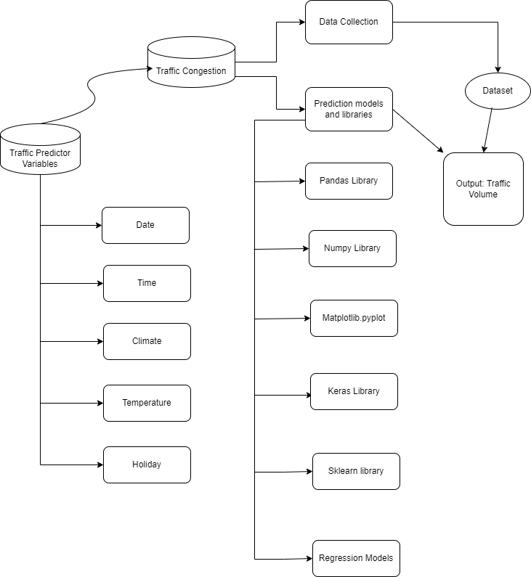

**User Stories**

Use the below template to list all the user stories for the product.

| **User Type** | **Functional Requirement (Epic)** | **User Story Number** | **User Story / Task** | **Acceptance criteria** | **Priority** | **Release** |
| --- | --- | --- | --- | --- | --- | --- |
| Traffic Manager | Real-time Traffic Estimation | USN-1 | As a Traffic Manager, I want to access real-time traffic volume estimations to make informed decisions for traffic control. | System provides accurate real-time traffic volume predictions. Data updates occur at least every 5 minutes. Data accuracy is within a 95% confidence interval. | High | Sprint-1 |
| Driver | Real-time Traffic Estimation | USN-2 | Application suggests a approximate congestion in the route. | Application suggests an approximate congestion in the route. | High | Sprint-1 |
| Traffic Analyst | Data Insights on congestion volume | USN-3 | As a Traffic Analyst, I want a Volume number displaying in-depth traffic insights for informed analysis and decision-making. | Volume number showcases traffic trends over various timeframes. | Medium | Sprint-2 |
| Website Developer | Model building | USN-4 | As an Web Developer, I want access to models that integrate TrafficTelligence data for incorporation into existing navigation applications. | Models provide accurate traffic data. Well-documented Models for easy integration. Allows access to real-time and predictive traffic estimations. | HIgh | Sprint-3 |